

**Placement Empowerment Program**

***Cloud Computing and DevOps Centre***

***Set Up a Local Git Repository: Initialize a Git repository locally and version control your static website***

Name: Jaswanth Saravanan

Department : ADS

**Introduction**

Version control is a fundamental practice in software development that allows you to manage changes to your code over time. It provides a systematic way to track updates, collaborate with others, and revert to previous versions if needed. Git is one of the most widely used version control systems

**Overview**

1. **Installing Git**: Ensure Git is installed on your system and properly configured.
2. **Creating a Local Repository**: Initialize a Git repository in the root folder of your static website
3. **Staging and Committing Files**: Add your project files to the staging area and commit them to the repository to save a snapshot of your work.
4. **Reviewing the** evolves. **Repository State**: Use Git commands to check the status of your repository and verify that everything is tracked properly.

**Step-by-Step Overview** :

Step 1:

Search Github in your browser and login to it .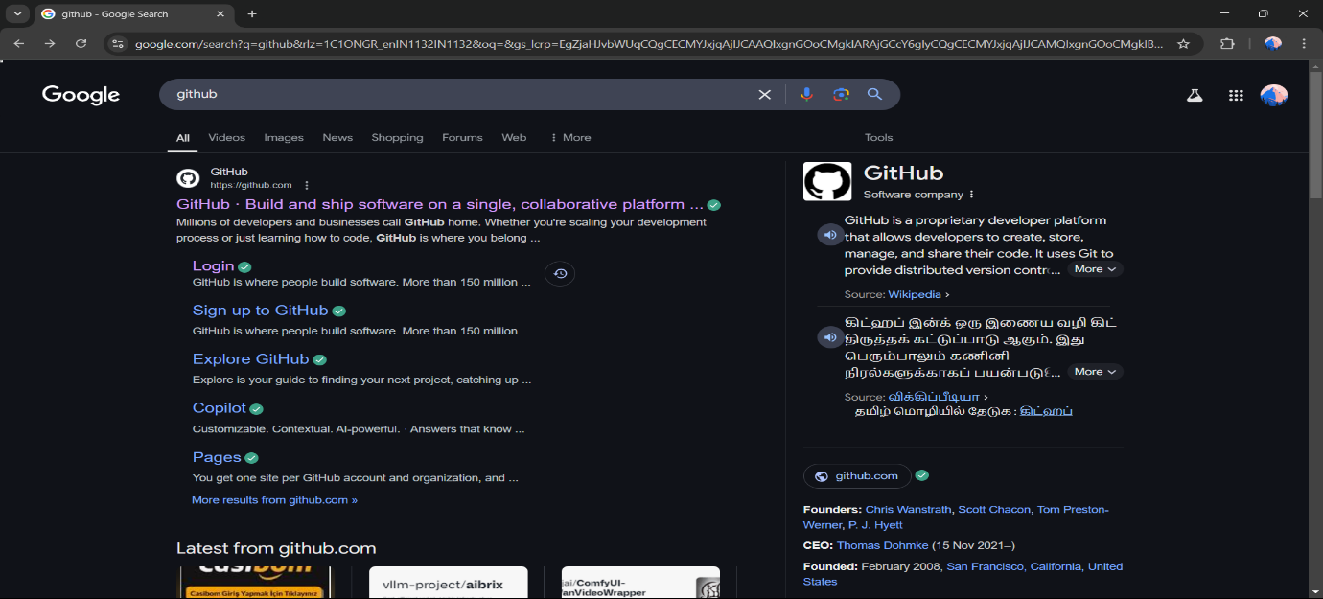

Step 2 :

In this step , find the plus symbol in the right side top and select the option “New repository”.

Step 3 :

Make a new name for your repository and customise the option that you want as private or public .

Step 4:

After initialising a new name for your repository choose an option – create a new file (or) open an exiting file .

Step 5:

Inside your repository type the content that you want and “COMMIT CHANGES” as you save the file .

Step 6:

Install “Git” to your system with correct version that you want to install

Step 7 :

Open command prompt in your system and type a git in it and the prompt will display like this , so you can ensure that git is successfully installed in your system.

Step 8 :

After installing git in your system set the user and email id in the system by the comment “git config—global user.name (as the user name in the github)” and email as well.

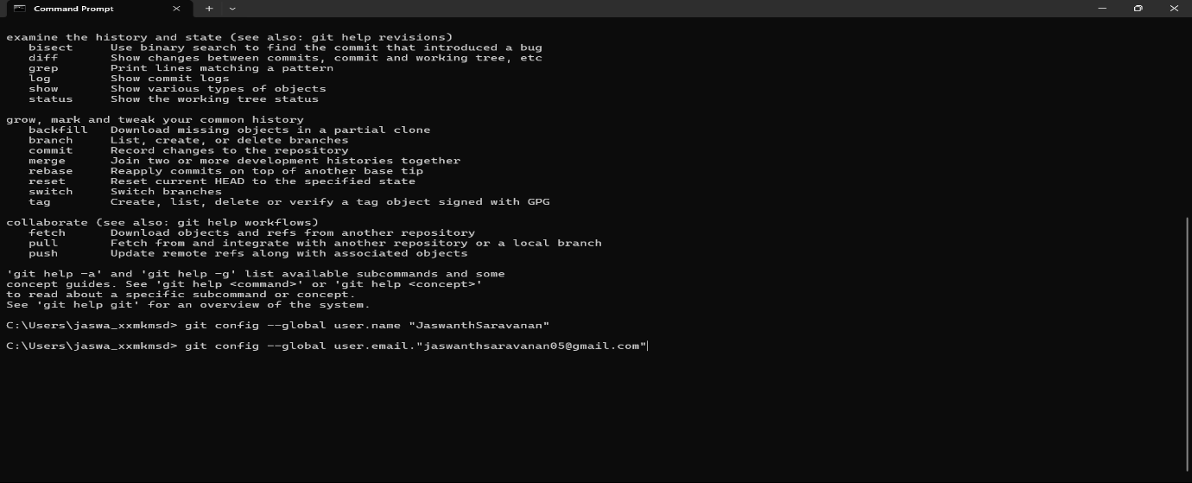

Step 9 : Open Visual code and with new floder .

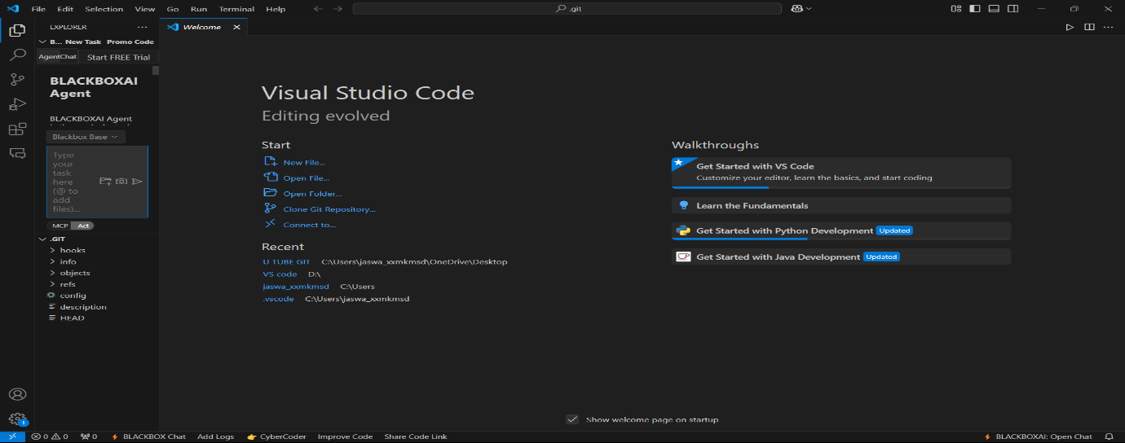

Step 10 :

To copy the floder from Git to our local System , open terminal in VS code and type “git clone “ and copy the code from the repo called origin , now the git floder openes in our local system

Use cd “filename” , so the file in our github profile will be seen in your local repository

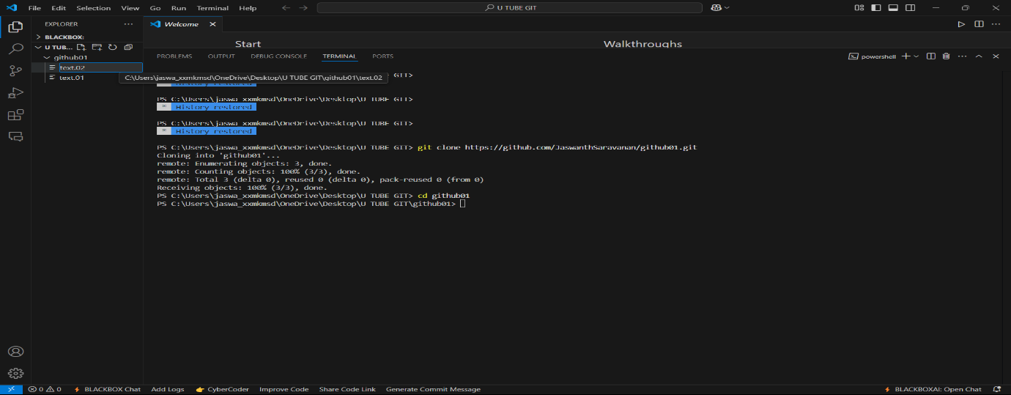

Step 11: use “git status” comment to view the status of the github account . If we add a new file in our local system in shows as “U” which means untracked , then comment “git add file name” now the file will be in the Stagging area “A” .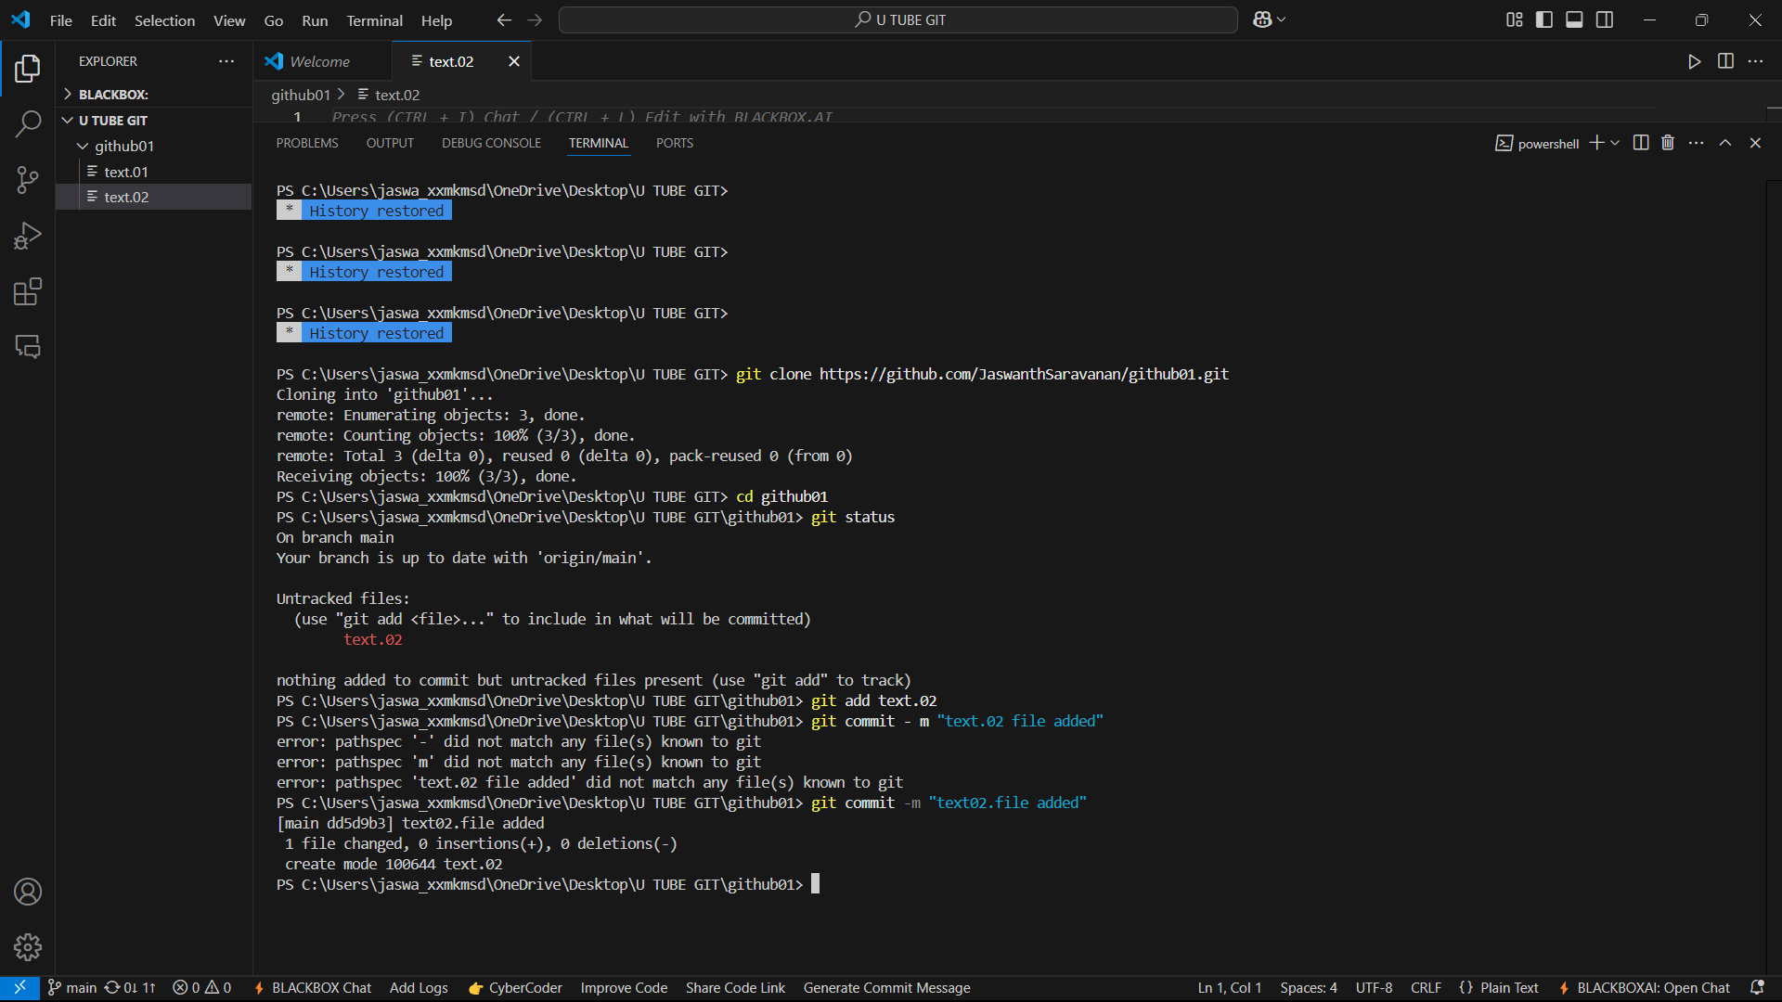

Step 12 :

Then use “git commit-m “text.02 file added” , now the file is commited to account .

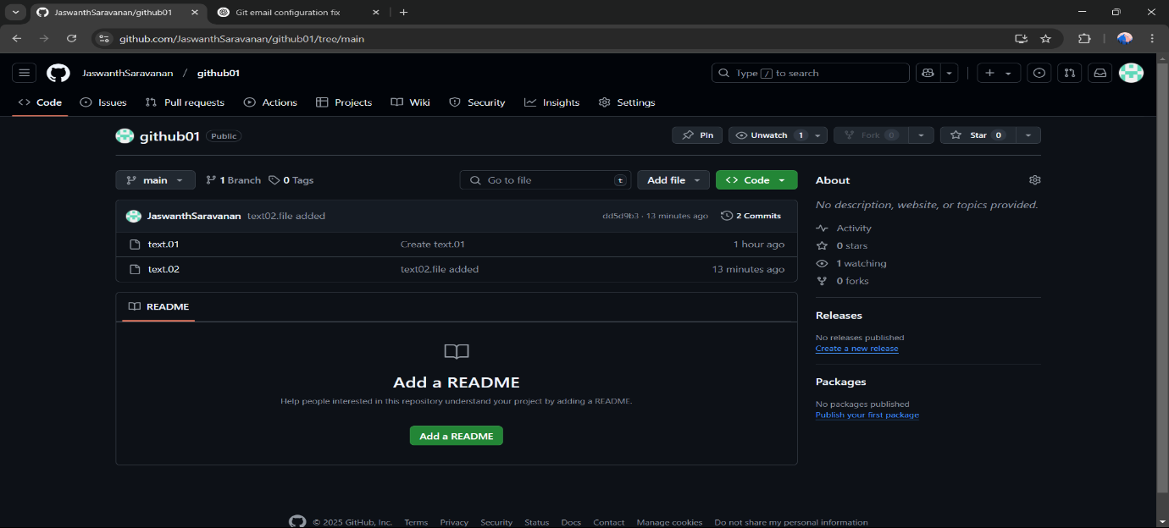

**Expected Outcome**

By completing this PoC of setting up a local Git repository, you will:

1. Successfully initialize a Git repository in your local static website folder.
2. Track changes made to your website files (HTML, CSS, etc.) using Git version control.
3. Understand the basic Git commands (git init, git add, git commit) for version control.
4. Commit your changes locally with a descriptive commit message.
5. Gain hands-on experience with Git and how it helps manage and track website file changes.